Vet Clinic _______________________________________________________
Owners Name____________________________________________________
Pets Name_______________________________________________

Necklace OR Urn ordering:_________________________________

Please print below exactly as you would like it on your product. There is space for a name and image on a necklace. Up to 3 lines of text for urns (images welcome).

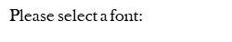
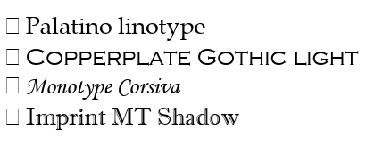

Other Special Requests: ______________________________________________________________________________________________________________________________________________________________________________________________________

